Affected by Harvey?

Affected by Harvey?
If you are in need of assistance please contact one of the Disaster Case Management Agencies listed below. Our agencies are faith based organizations united in assisting residents of Victoria County that were affected by the disaster and who do not have adequate personal resources to complete their recovery as a result of the Hurricane Harvey Disaster.

If you are in need of assistance please contact one of the Disaster Case Management Agencies listed. Our agencies are faith based organizations united in assisting residents of Victoria County that were affected by the disaster and who do not have adequate personal resources to complete their recovery as a result of the Hurricane Harvey Disaster.
(361) 703-5567
Counties: Victoria

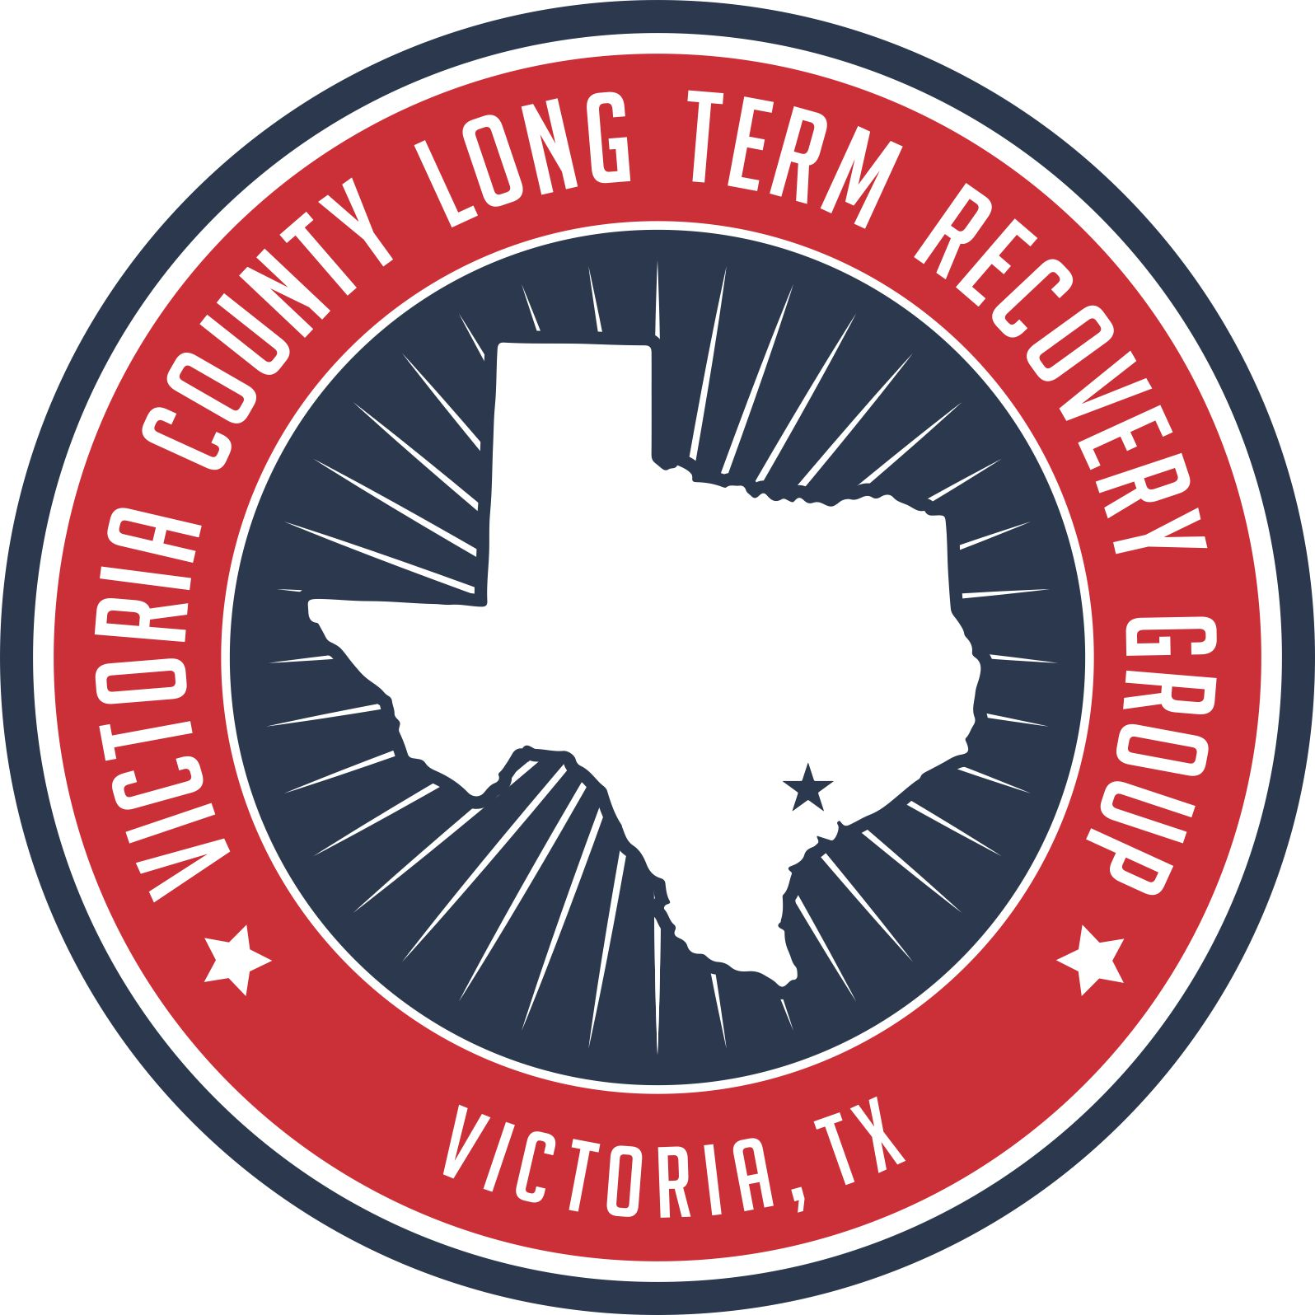
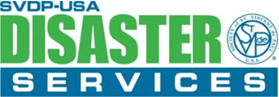

(409) 651-5637
(409) 651-5631
Counties: Victoria, Wharton, Jackson, Aransas, and Nueces
Counties: Victoria, Wharton, Jackson, Aransas
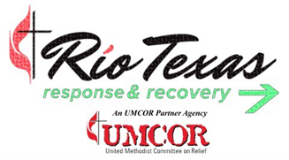

(361) 851-7401
(361) 851-7401
Counties: Fayette, Caldwell, Colorado, Victoria, Goliad, Lavaca, Karnes, Gonzales, Calhoun, DeWitt
VICTORIA COUNTY LONG TERM RECOVERY GROUP

207 N. Glass St.
Victoria, Texas 77901
Phone (361)703-5567
Fax (361)703-5569
www.victorialtrg.org

“victoria strong”

Hurricane Harvey Recovery

(512) 922-8195
(512) 922-8195
Counties: Victoria, Calhoun, Lee, Bastrop

Interested in giving a helping hand?
Please contact
Daniel Harasim
(361) 894-9334
To apply for volunteering!

For additional information please visit our website:
www.victorialtrg.org
or visit us on
@VLTRG

Partnering organization programs
- Homeowner’s Assistance Program
Helps repair and rebuild homes
2208 Leary Lane Victoria TX 77901
(361) 485-0000

- Habitat for Humanity Program
Helps repair damaged homes
4103 N Navarro St. Victoria TX 77901
(361) 573-2511

- Samaritan’s Purse Programs
- Manufactured Home Replacement Program
Application for this program, contact:
Cindy Barton (281) 714-8418
Tracy Porter (346) 242-3603
- Homeowner Material Assistance
- Repair Program
For applications please contact:
Last name starting with
A-E (361) 230-2570
F-P (361) 230-2561
Q-Z (361) 230-2570

.
HOPE MEADOWS
Applications are now available for those interested in applying for a home in the Hope Meadows subdivision. Hope Meadows Development application is available at any of the Disaster Case Management offices assisting Hurricane Harvey survivors.
The VCLTRG, Mennonite Disaster Service, Disaster Aid Ohio, Rio Texas UMCOR, Civil Corp., Cullen Law Firm, First Community Bank of Victoria and other partners have combined their expertise and resources, totaling approximately $4.6 million, to build 40 homes that will bring surviving families into full recovery. The infrastructure should be complete in the Fall of 2019 with home building beginning shortly thereafter.
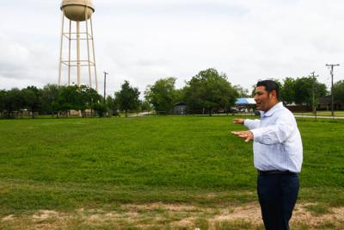
WE’RE HERE TO HELP
Ashley Razo
Disaster Case Manager Supervisor
Ashley.razo.vcltrg@gmail.com
(361) 894-9304

Lisa Steen
Disaster Case Manager Lead
Lisa.steen.vcltrg@gmail.com
(361) 894-9303

Bruce Salzman
Disaster Case Manager
Bruce.salzman.vcltrg@gmail.com
(361) 894-9305

Theresa Martinez
Disaster Case Manager
Theresa.martinez.vcltrg@gmail.com
(361) 894-9307

Briana Flores
Disaster Case Manager
Briana.Flores.vcltrg@gmail.com
(361) 894-9346

Rick Villa
Development Coordinator
Rick.villa.vcltrg@gmail.com
(361) 894-9333

Daniel Harasim
Warehouse/Volunteer Coordinator
Daniel.harasim.vcltrg@gmail.com
(361) 894-9334

Travis Hawes
Project Manager
Travis.hawes.vcltrg@gmail.com
(361) 894-9306
Company Name
Street Address
Address 2
City, ST ZIP Code
Phone (555)555-0125
Fax (555)555-0145
Web site address

